**Sequence Diagram**

**LogIn**

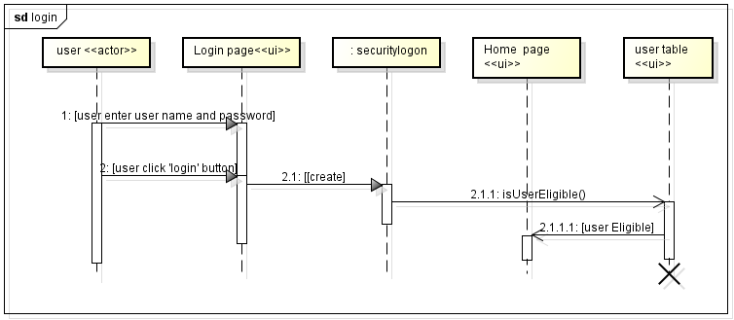

**Generate Report**

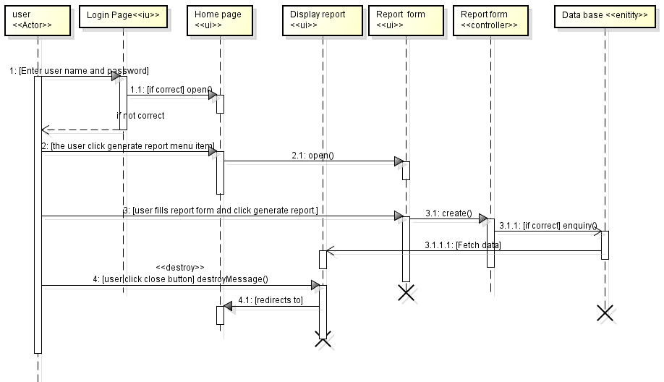

**Enable Account**

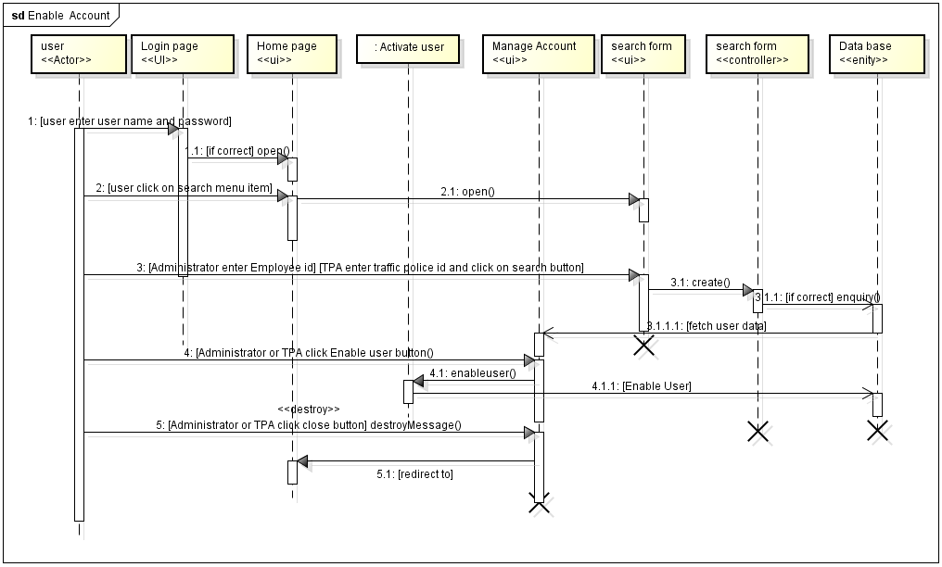

**Disable Account**

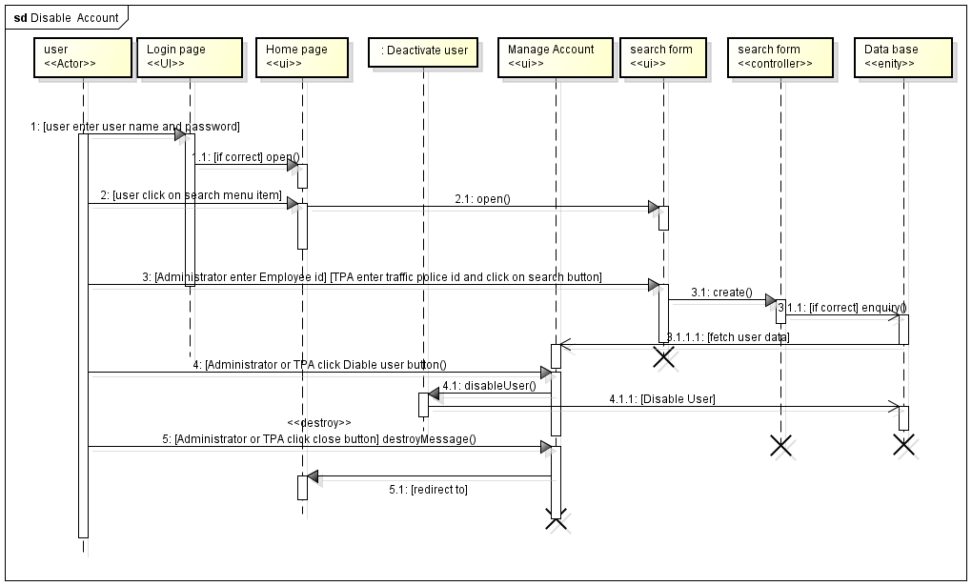

**View Self Profile**

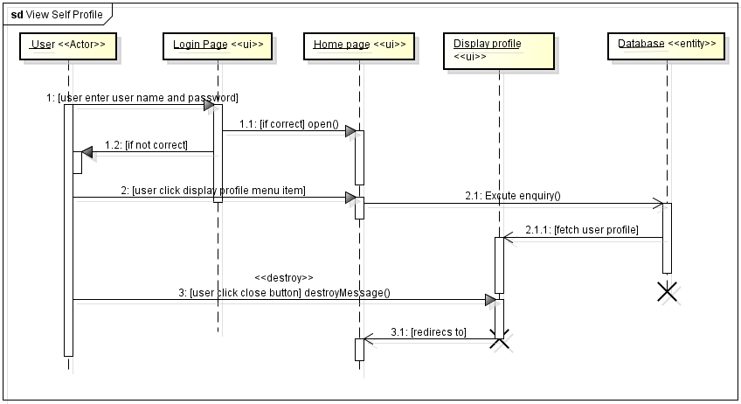

**Change Password**

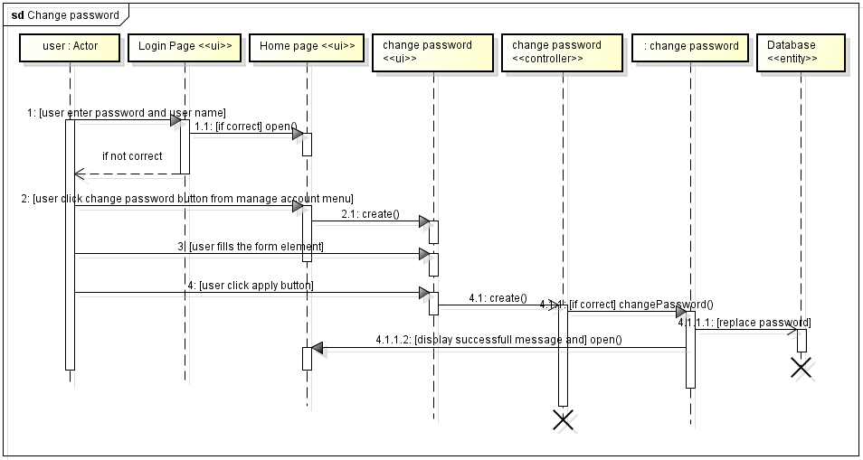

**Register Traffic Police**

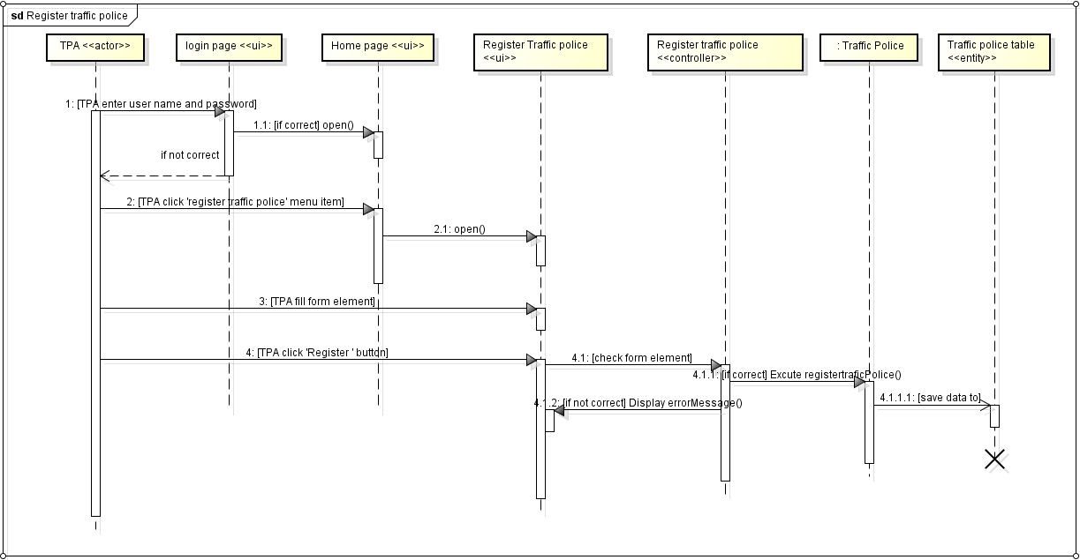

**Register Driver**

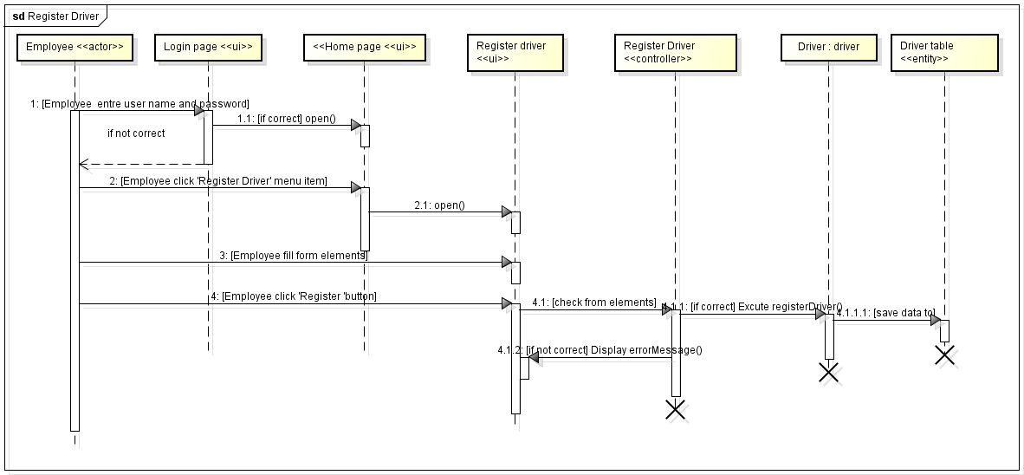

**Register Vehicle**

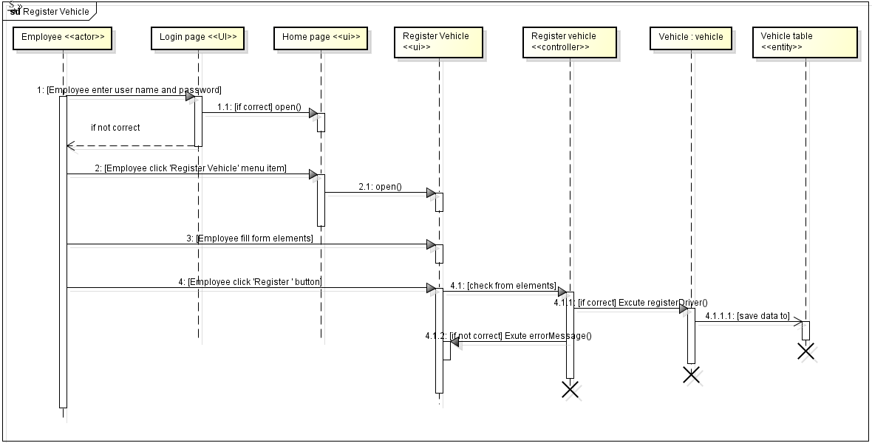

**Register Employee**

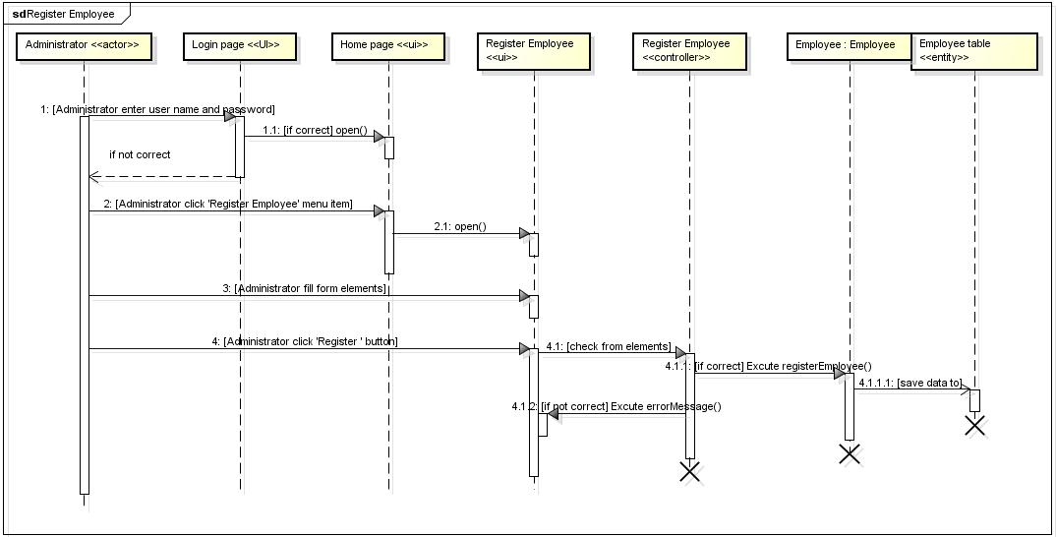

**View Employee Profile**

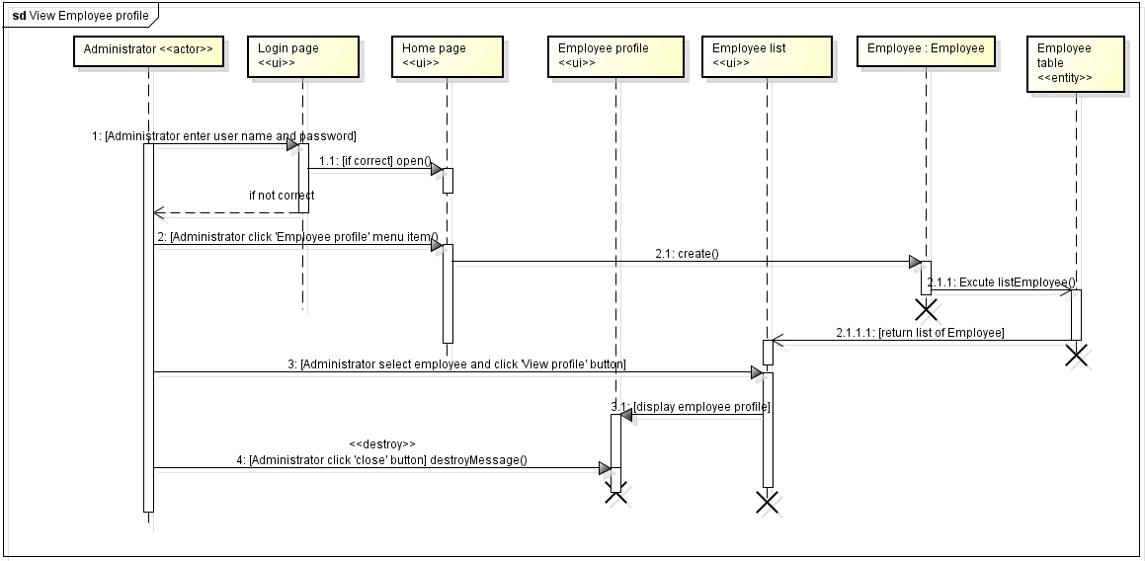

**View Driver Profile**

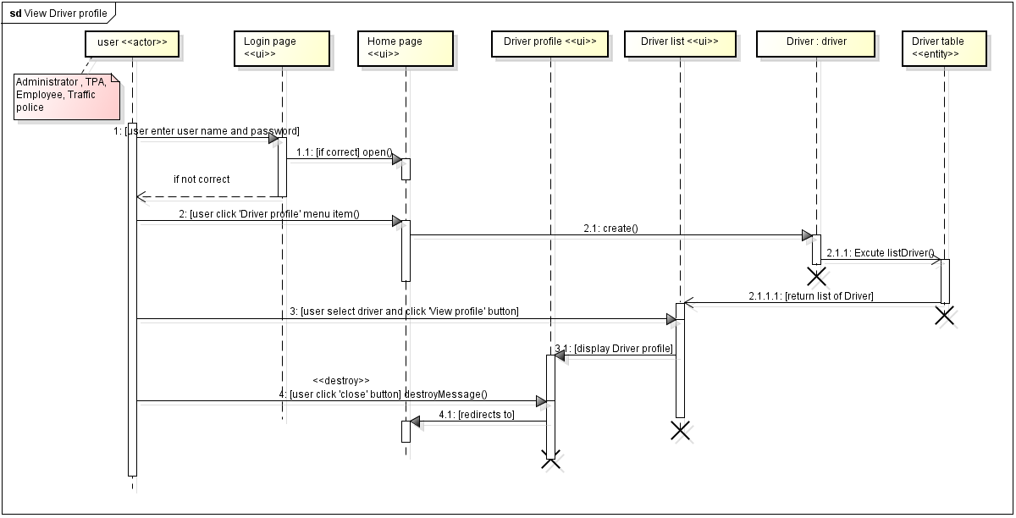

**View Traffic Police Profile**

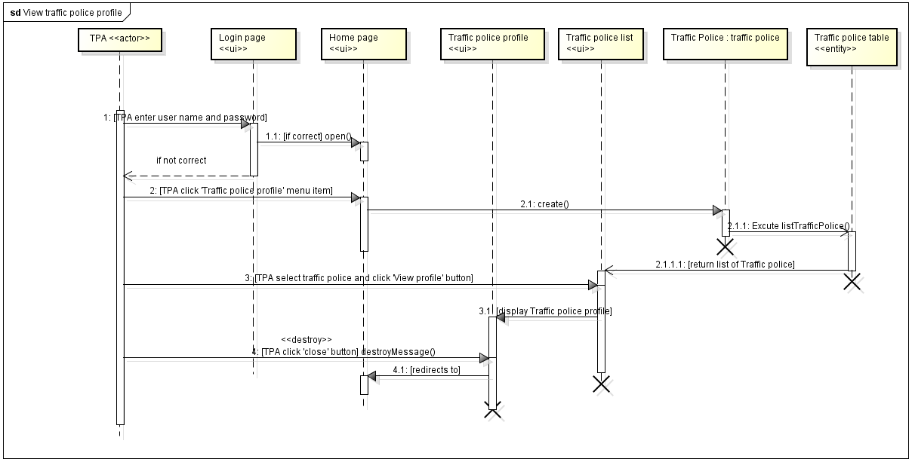

**View Vehicle Profile**

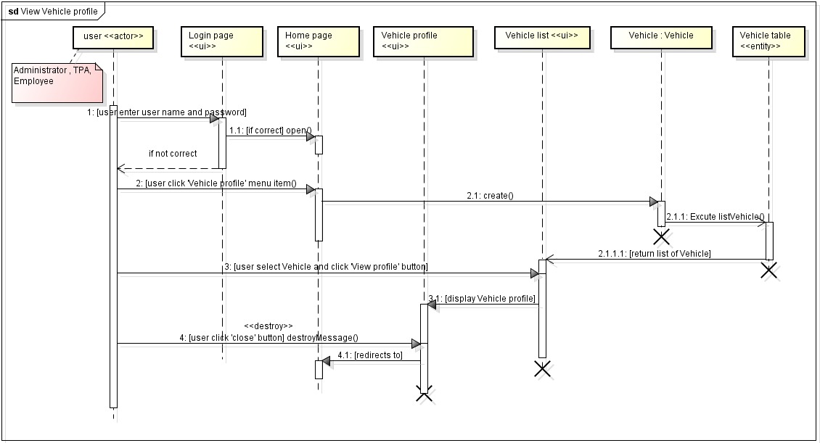

**Punish Driver**

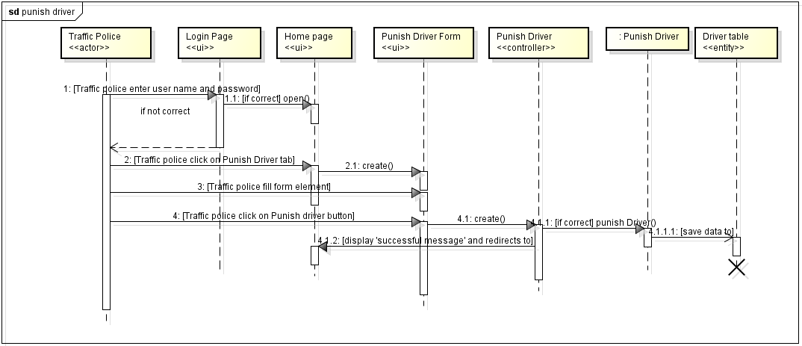

**Activity Diagrams**

**Login**

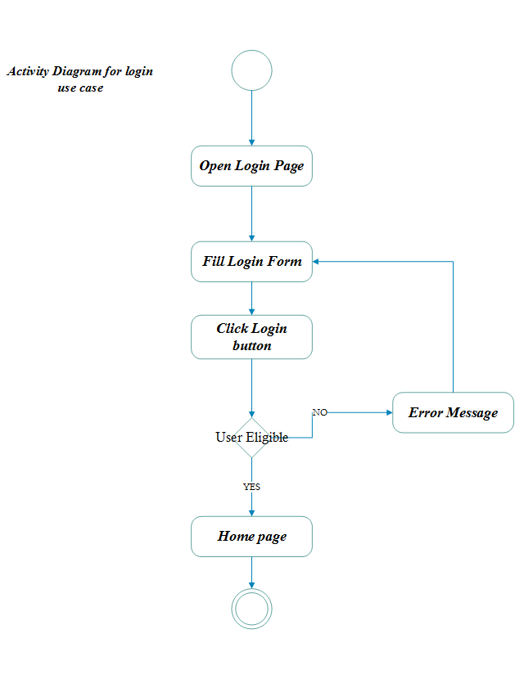

**Logout**

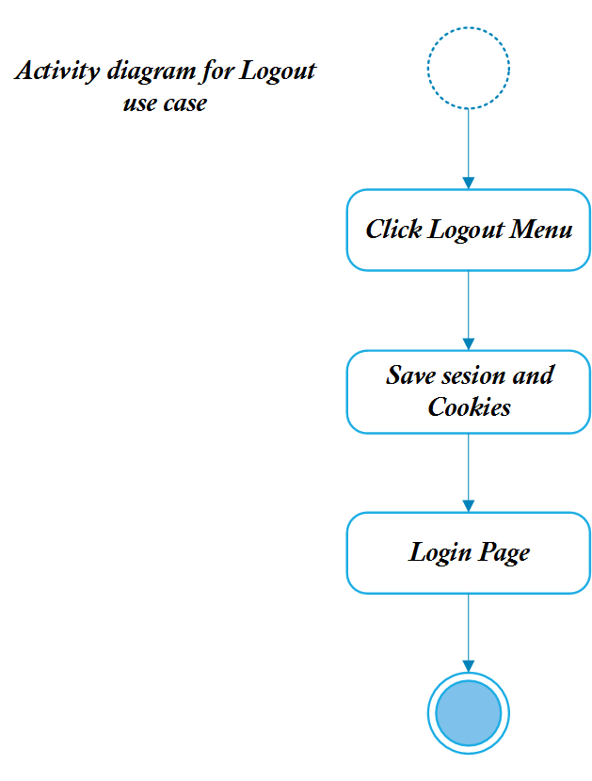

**Generate Report**

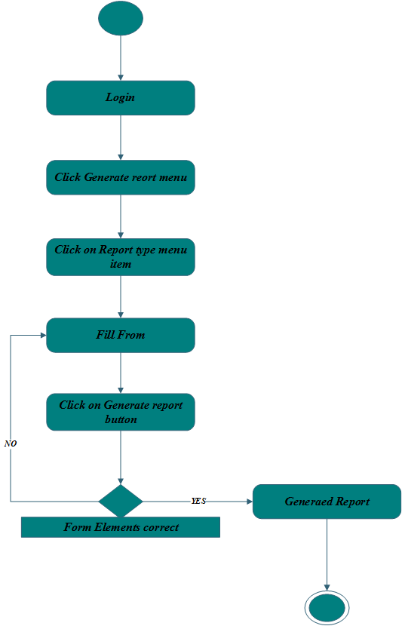

**Enable Account**

**View Self Profile**

**Change Password**

**Register Traffic Police**

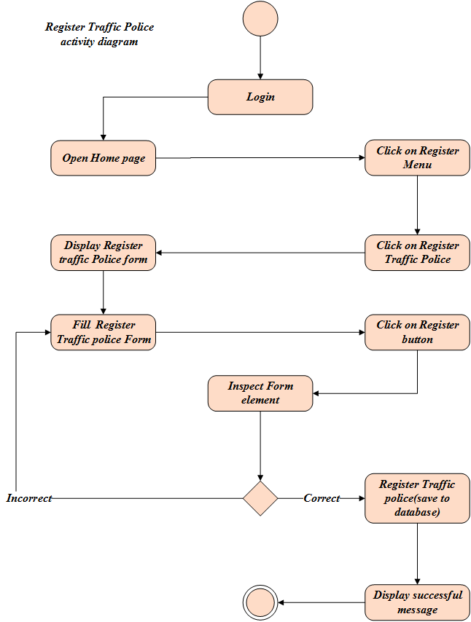

**Register Driver**

**Register Vehicle**

**Register Employee**

**View Employee Profile**

**View Driver Profile**

**View Traffic Police Profile**

**View Vehicle Profile**

**Punish Driver**

